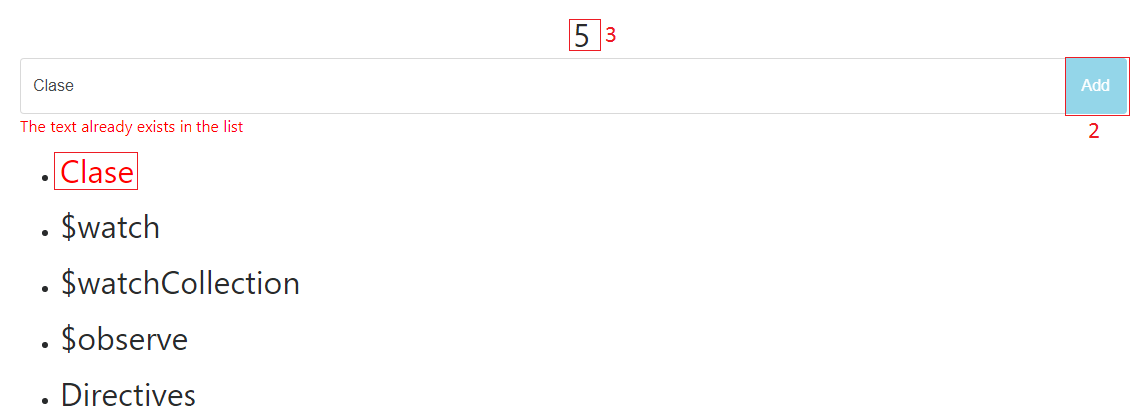

Instructions:

* Create a directive which shows an iterate list.
* In the index.html create the input text, the button and call the directive.
* The button will fill the list only when a specific model changes, so by this way the $observe will be triggered.
* Create a counter which is incrementing every time that I push a new element in the list (The list should have a $watchCollection to increment the counter) - 3
* Disable the button when there is no text added or when the text is currently in the list (Use $watch for this point) - 2
* Create a new directive which adds a class to the list to show to the user that the text is current in the list - 1